Ejercicio B Tema 1

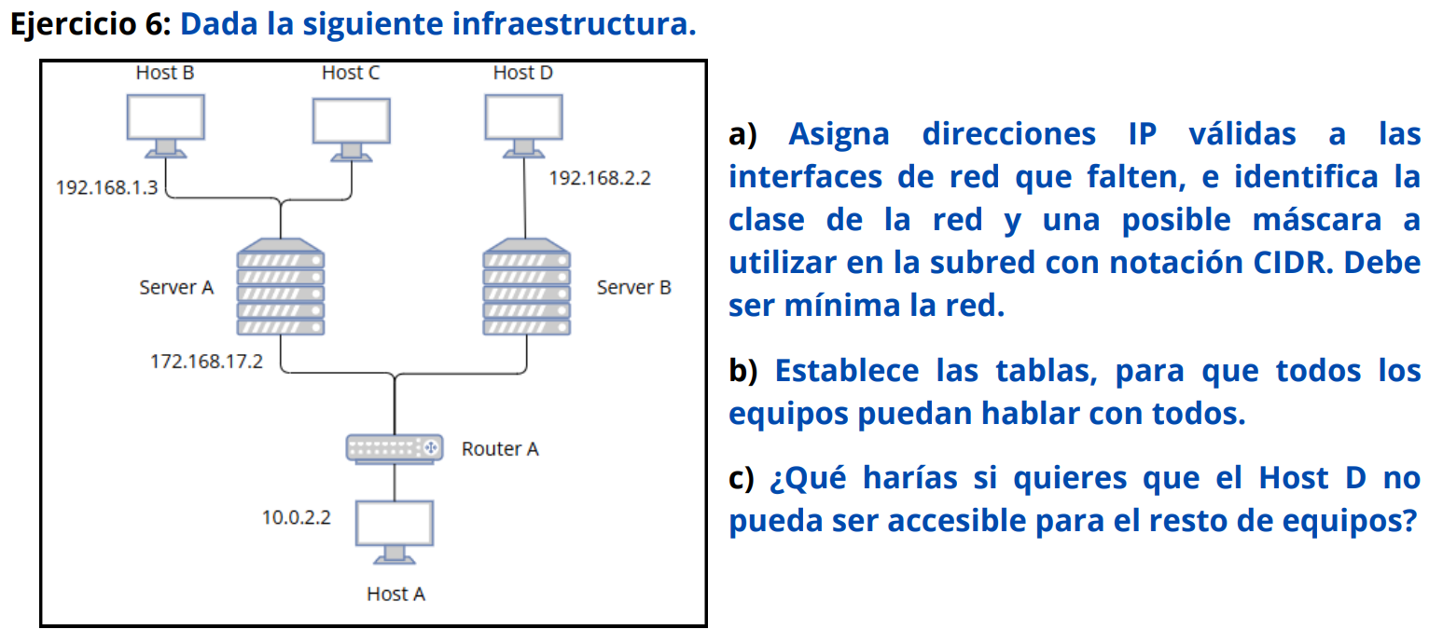

A)

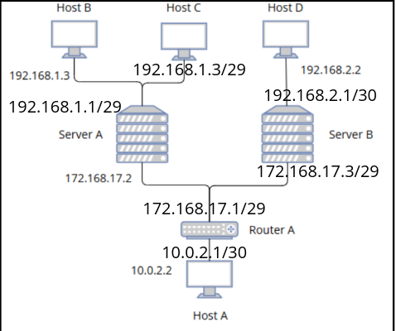

B)

ROUTER A

| 10.0.2.0/30 |  |
| --- | --- |
| 172.168.17.0/29 |  |
| 192.168.1.0/29 | 172.168.17.2 |
| 192.168.2.0/30 | 172.168.17.3 |

SERVER A

| 10.0.2.0/30 | 172.168.17.1/29 |
| --- | --- |
| 192.168.2.1/30 | 172.168.17.3/29 |
| 192.168.1.3/29 |  |
| 192.168.1.2/29 |  |

SERVER B

| 10.0.2.1/30 | 172.168.17.1/29 |
| --- | --- |
| 192.168.2.2/30 |  |
| 192.168.1.3/29 | 172.168.17.2/29 |
| 192.168.1.2/29 | 172.168.17.2/29 |

C) usando reglas acceso en el server B para que no pueda acceder desde otros dispositivos